

**Data Driven Decisions for Healthcare**

Sogeti, Microsoft, and HP have formed a unique partnership to accelerate industry specific solutions which assimilates and analyzes disparate and huge quantity of data into meaningful information for business users via a self-service mode by leveraging the advantages of Microsoft’s Analytics Platform System, Power BI via Office 365, HP’s ConvergedSystem 300 for Microsoft Analytics Platform System, Microsoft Azure, and tablet devices, combined with Sogeti’s technology and industry expertise and thought leadership.

A key focus of the said partnership is to administer a singular healthcare solution, the need of which has been created by the Affordable Care Act (ACA). One of the key goals of the ACA is to financially incentivize providers to proactively care for chronic patients in the out-patient (OP) setting; thus keeping them healthy, happy and away from high-cost acute care facilities/hospitals. Hence, the principles of ACA-reducing avoidable cost while improving quality and patient & physician experience- are addressed.

The tripartite partnership accelerates the ability to grant insight across the continuum of care by analyzing services provided by a given clinician versus those at outpatient facilities. This would give valuable insight into the services provided within a certain hospital’s primary or secondary service area, as an example. In order to give providers an additional dimension to understand their market, the solution also demonstrates the analyses of trends in web searches related to healthcare by the population residing within a certain care facility’s zip code versus actual services provided in a similar time period. This enables clinicians to target their preventive care campaigns to the appropriate patients and more.

Additionally, the HP-Microsoft-Sogeti-powered solution explores the use of Twitter and other social media data, for creating an improved ‘Healthcare Emergency Notification Plan’ for the Provider. Such information could supplement the provider's existing notification channels and give them an additional tool to prepare for emergencies.

A unique, simple way to use solution that assists in Proactive Care:

• Helps preemptive and categorical identification of high-risk and complex chronic patients

• A Care Provider’s key tool to assimilate, synthesize and get insights into both OP and IP data

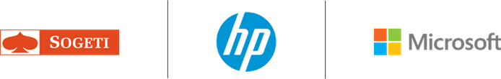• Assist in reducing avoidable cost of care, while improving care quality

For more information please visit www.us.sogeti.com/